## **Project “Dragon” 1.5 Page GDD**

*Diablo meets Monty Python*

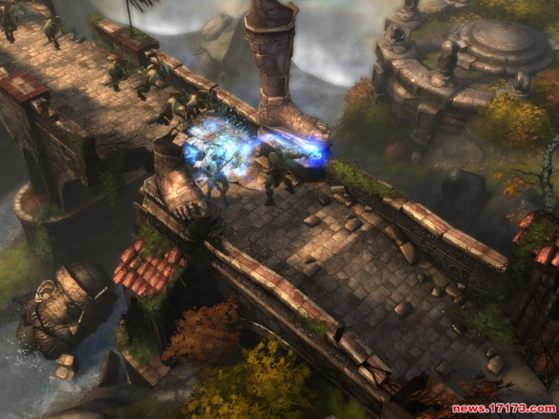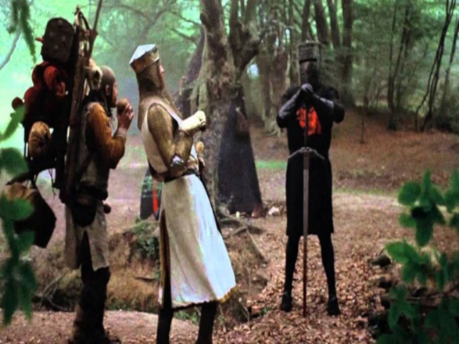

**Genre:** Fixed-camera, Single Player, 3rd-Person Action RPG  
**Target Audience:** 13 yrs.+ fans of old school RPGs like Diablo. People who like comedy. Rated T for Teens.

**Controls:** Mouse & keyboard.

**Thematic Setting:** Medieval Europe / Fantasy / Knights and Swords and Dragons and stuff

**Tech Stack:** Unity 2018.3 with C#. Audacity for SFX. Asset store asset packs for art.

**Platform(s):** Steam

**MVP Game Moment:** 2 minutes of simple linear level flow with basic combat (hitting and taking damage) against 3 or 4 enemy types.

**Game Summary:** Project “Dragon” is a Diablo style RPG with the absurd humor of Monty Python and the Holy Grail. The game is set during the grubby phase of the medieval era when brave Sir Knights were bold and foolish, and the unbathed peasants reeked of cabbage. As our unlikely, elderly hero, you must battle the Queen’s soldiers and grotesque monsters by finding ancient weapons, leveling up your character, venturing to far off lands (using special “*Wizard magic”* known as “meta-map fast-travel”), and seeking answers to the ultimate riddle - “Who am I and why *are* dragons such jerks?”

**Core Player Experience:** Funny / The joy of laughter

**Central Story Theme:** The unlikely hero.

**Design Pillar:** Putting the player in absurd / funny / ridiculous situations.

**Anticipated Remarkability:** Absurd humor.

**Anticipated Steam Early Access Launch date:** End of 2020

**Feature Development Priorities:**

* Real-time combat with tons of different enemies to smash
* All the required RPG abilities and stats (upgradeable)
* Level building and game progression
* Branching dialogue system
* Inventory, loot, usable items

**Reference Games:** Ember, BattleHeart:Legacy, Diablo, Torchlight 2